Level 6 "Cal" is characterized by 18 scenes , as well as 4 (*) situations in which it is possible to talk freely.

1 where they open the door of the walls

The team has just passed the last hill of the roaring Hills and finally sees the great walls of Cal in the distance.
S: Here it is! It's Cal! Finally, who knows if Howl is still there. Oh! I wonder if he's prisoner!
H: Uooof! Uof! .. Cal! Caal!
Heen transforms his self continuously, changing what he says based on his form. Meanwhile, he goes around Calcifer.
C: Heen stop it.
M: it's very far away! we won’t arrive before evening!
S: You're right, hurry up.

The team is outside the city walls, near the secret door
S: We should have arrived, but I don’t see any door.
C: it's magical! We detect his presence
WoW: yes, yes, we are dealing with a beautiful antique door.
Leaning on his magic stick, the witch of the lands approaches the walls and reveals the door tracing its perimeter.
M: uooo incredible, I've never seen anything like this.
S: perfect, now we just have to pass it before a patrol come through the walls.

Once the enigma is solved, the door opens wide
S: never let it be said that a magic door refuses to let me in.

2 where they arrive stealthily to the tavern

Beyond the walls, the team wanders through the city’s alleys.
M: what a dark place here, Calcifer do a bit of light.
S: no Calcifer, stop! You will expose us, in fact, lower the visor of the armor.
Calcifer lowers the visor and the alley becomes even darker.
C: and here we are, completely in disguise.

Once arrived outside the tavern they see that inside it’s slightly illuminated.
C: To us it looks like a trap
S: why would you say that? what was you expecting, a welcoming committee?
C: no, it's not for the silence, the whole city seems deserted. The problem is that we feel strange energies coming from there.
M: in any case we wouldn’t know where else to go ..
WoW: I have to sit down, I’m sick of this stick.
The Witch of the Lands approaches the door and waits for Sophie.

3 Where they enter the tavern full of monsters
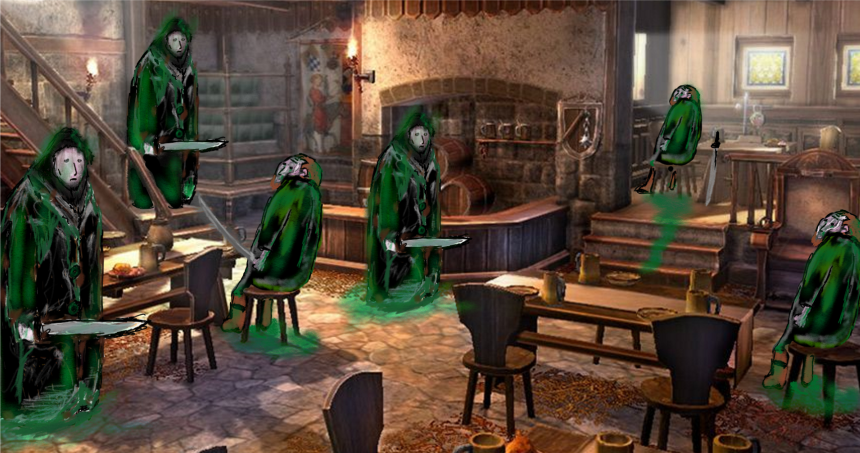
Sophie opens the door and the Witch of the Waste and Heen, in the form of a warrior, enter next to her. They find the Layton’s soldiers in a catatonic state, some sat sloppy, others standing, staring into space. After a few moments, however, all of them turn around the neck to look at the team, as if, lost in their thoughts, have been distracted by the sound of the door. Sophie is the first to react and instructs Calcifer to throw lava spouts all over the place, while hitting the nearest monster with a spell. Behind her, Markle hides full of fear as the witch of the lands rushes to the assault.

4 Where Ben arrives in the tavern and they escape from the roofs

As they finish victoriously, Ben comes downstairs, down the stairs leading to the upper floor.
B: soon! Go upstairs! Many others of them are coming, you have made a mess!
S: and who would you be?
B: for now it is enough to know that I fight by your side and that I am not covered with mud.
At the end of the battle they go to the first floor of the tavern.
B: My name is Ben, I am a guard of Cal, loyal to the great King Beuron, you rather, how did you end up in the old base of the resistance?
Meanwhile, he looks at them worriedly, with particular attention to the old witch.
S: we're looking for Howl the wizard, he's been missing for days.
B: Ah! Just as I imagined, you are Howl's companions! Then you are also my companions. You, old woman, do you think you can jump from roof to roof with that old stick? You know, it's really an emergency.
The witch of the lands stares Ben with love.
WoW: my beautiful young man, if the stick was not enough, I studied in my life at least a thousand spells even more useful to the task. I think I should remember at least one.
B: and you? With that armor?
Calcifer uses the arms of the armor to lift the empty iron bust.
C: we are self-sufficient, worried at most to keep the child and that dog away from our feet.
And so the group hurries to proceed on the roofs.
S: So you met Howl? In Salt Marina they said that King Beuron gone mad, and that Howl therefore quelled him.
B: He did much more, he saved the king from Layton's mental manipulation! Unfortunately, however, immediately afterwards he disappeared. He headed for Layton's fortress with a handful of soldiers. But it's been four days now.
S: do you think they were defeated?
B: I don’t know how else to explain their missing.

5 Where they see Layton flying while they arrive at the base of the resistance

Shortly before their arriving at the base where Cal's survivors and resistance are hidden, Calcifer perceives great magic power over their heads: Layton flies over the city to the tavern they have destroyed, which still burns in the night. After they went down on the road, Ben traces with his finger a symbol on a manhole, which opens on its own. He informs them that Howl has helped them find the new hiding place, after which they dive into it.

*

In the hideout, Sophie can talk to more survivors, as well as to team members.
Calcifer: Did you see how it flew in the night? It seems very powerful, he gives me the heebie-jeebies! And he loses slime wherever he goes, like an infector.
S: yes, he is a fearsome adversary, and he gives me nausea. I hope that we will find Howl soon and defeat him.
Markle: How many cheerful people in here, it seems that good humor is useful to increase their resistance to the slime !
S: then you must be really resistant!
M: Yeah, but I've always feared the blades of Layton's servants more than the mud.
Heen: Heen defeats Layton with the sword.
S: it's still early to face Layton, we have to train! You still have to find many of your parts!
H: if Heen returns like the Heen uses to be, he is invincible!
Xaion the warrior: Welcome, I hope you can rest. There is always a great din here.
S: are you a soldier of the resistance?
X: That's right, I'm Xaion, and I fight to free Radme.
Marion the smart: Come from outside Cal? Once I used to smuggl from an exit of the south gate, how did you get in?
S: from the south gate, but we had many difficulties
M: it becomes increasingly difficult to leave the city. If you meet Victor outside, could you give him this letter? From Marion.
Ektor the tightrope walker: I am Ektor, and I walk on ropes. Since no one pays a ticket to see my show, I do not have a place to stay. I try to make myself useful as I can.
Zip the merchant thief: Hi adventurer, before leaving for the next adventure come to buy the from zip!
S: what do you sell?
Z: all that is useful left in the city, if you need something that I do not have in store, I go out and I steal it only for you, mt darling.

the following two dialogues are useful to the plot
6 the witch of the lands observes the orphan child

WoW addressed to OC: look that beautiful child, just beautiful!
S addressed to WoW: but you were not already tired before arriving at the tavern? You should rest!
WoW addressed to OC: and what a heart! -interrupting- It is a big and noble heart!
Meanwhile, the Witch observes closely the child, who tries to wriggle, and finally manages to escape.

7 Where Ben talks about the sidequests and the main mission

When Sophie come to talk to Ben, she is followed by all the other members of the team
B: You met some members of the resistance. Many of them lost everything, their family members and everyone they knew fell victim to Layton's spell, and now they are fighting each other.
-S: how to help the resistance
B: since Layton discovered us, we are short of weapons, while Layton has almost all the army with him. His soldiers are slow, but even stronger than in human form. In addition we need food, Layton knows almost all the accesses to the city, to communicate with the roaring hills we need a new road
-S: the weapons
B: We intended to attack the armory frontally, but you will be able to infiltrate and escape unharmed. You will have to leave the hiding place from the north exit, and follow the lanes always north until you reach the barracks, near the walls. There you will take possession of as many weapons as you can, and sabotage the pillars of the building with dynamite. Thank you so much for what you do.
-S: the new road
B: We will have to get to the walls from the east exit, reach the ancient passage in the walls and free it from obstacles, traps and monsters, to allow scouts to pass. You will be led by one of my most trusted soldiers who knows the ancient code to open the passage.
-S: latest news from Howl
B: Howl saved the King from Layton's spell, and with him his loyal escort. Then he helped Beuron to organize the resistance, which I led in his stead while he was under the curse. The same night, however, Howl decided to leave, with an escort of five men given to him by the king, towards the marshes. He was defeated, and the soldiers with him escorted to the castle, where they fell victim to Layton's spell.
S: it's terrible, we have to free them and talk to them!
B: I like your ardor, but the castle is the most watched place in Cal, and it will not be easy to access it .. we will have to study a plan. Come back to me when you are ready to decide how to act.

8 where they talk about the castle and the alchemist's guild

Sophie and the others reach Ben and listen to the plan
B: We will have to access the castle from the sewers, from there we can go out in the castle baths, which are exactly two floors below the throne room. There should be the soldiers we have to free, according to my informants.
S: Does he keep them prisoners in the throne room?
B: No, their wills have been inhibited. Layton placed them there because they are the strongest of Beuron's soldiers, and he wants to protect the throne room.. To cross the secret conduits we will have to use the precursor’s code. It is the key to opening the ancient portals. The only copy known to us is kept in the guild of alchemists. Go there and retrieve the code, then come back to me and I will show you the portal to access the canal that leads to the castle.

9 where the team meets the crazy alchemist

As soon as they enter the guild from a narrow passage, the team is wrapped in a thin fog, a laugh runs through the corridors and breaks the silence. The alchemist invites the team to overcome his enigmas.
A: dear presents, welcome in my stronghold. Here I resist Layton while I find a cure for his illness. For now the experiments are proceeding with full success, on me the slime does not cause loss of will. However, hhahahhahahha, I still have not completely healed
S: obviously he does not know that hot water is the only way to get rid of the slime, must get crazy trying to do it.
C: yeah! It gives me creeps!
M-worried-: maybe we should just tell him how to save himself
A -da outside the room-: Only a thief with an acumen like mine can overcome my riddles, and enjoy the last treasures of the guild.
M: HEEEEY ALCHIMIST! A HOT BATHROOM WILL DO TO HEAL YOU, LET US HELP YOU, WE ARE ENEMIES OF LAYTON!
A:….
S: obviously he can not hear us, I believe that the voice reaches us through a spell .. we will have to make our way to his room.
The team enters the guild hall.

10 where they find the book and leave the guild

They enter the alchemist's room and find it threatening, holding the ancient code to itself behind a counter full of alembics.
Heen growls.
A: Welcome, I must deduce that you have managed to overcome my enigmas.
S: yes and it's time for you to give up, we do not want to hurt you.
To: you have not been sent by Layton?
S: no, we are allies of King Beuron
A: So you're not going to steal my soul?
S: no, we only want the ancient code .. but you're full of slime, why you are not a monster?
A: endowed with a superfine mind, I did not get caught by the despair of the slime, and I found a solution that inhibits it. However I can not find a way to get rid of it. Injecting the solution is destroying my brain, but I still have not found how to get rid of this damn slime DEFINITIVELY.
S: it is enough to wash for several hours in hot water, it has worked with the cheaf of the roaring Hills, it will work with you too.
The alchemist remains a moment petrified for the revelation, then drops the code and runs to prepare the bath in the next room. Sophie takes the book.
S: good bathroom mister alchemist!

11 where they arrive with Ben at the ancient port of the sewers

B: do you have the code?
S: yes
C: it was guarded by a very dangerous madman, it’s been much more difficult than expected.
B: the important thing is that now you are here, unharmed. Follow me.
Ben leads them into a tunnel dug by the resistance, and they reach a canal full of water. A large circular gate of heavy iron prevents them from continuing. Ben calls Sophie and shows her a page of the book.
B: I can not go on, I will create a diversion on the other side of the city to make sure there are not too many guards at the castle. Sophie, look at these pages, they contain a translation of the symbols of the ancient language. By deciphering the incisions you can open up passages built by precursors throughout Radme. Let's try to solve this portal together.

12 where they comment on the sewers and the enigmas

M: I had no idea that there was a civilization before the current one in radme. Judging by these structures it was quite advanced!
WoW: it was, they were certainly more technologically advanced than the current inhabitants of radme. Not to mention their mastery of magic, superior to the best wizards of Ingary. The legend tells that a natural disaster made them disappear.
M: and the current inhabitants?
WoW: they are settlers, emigrated from our continent many years ago.

Crossing a pool of water
C: This place is wet, we do not like it. We have the armor full of water.
H -swims like a dog-: uuuff uuuuuff!
S: resist Calcifer, we're almost there!
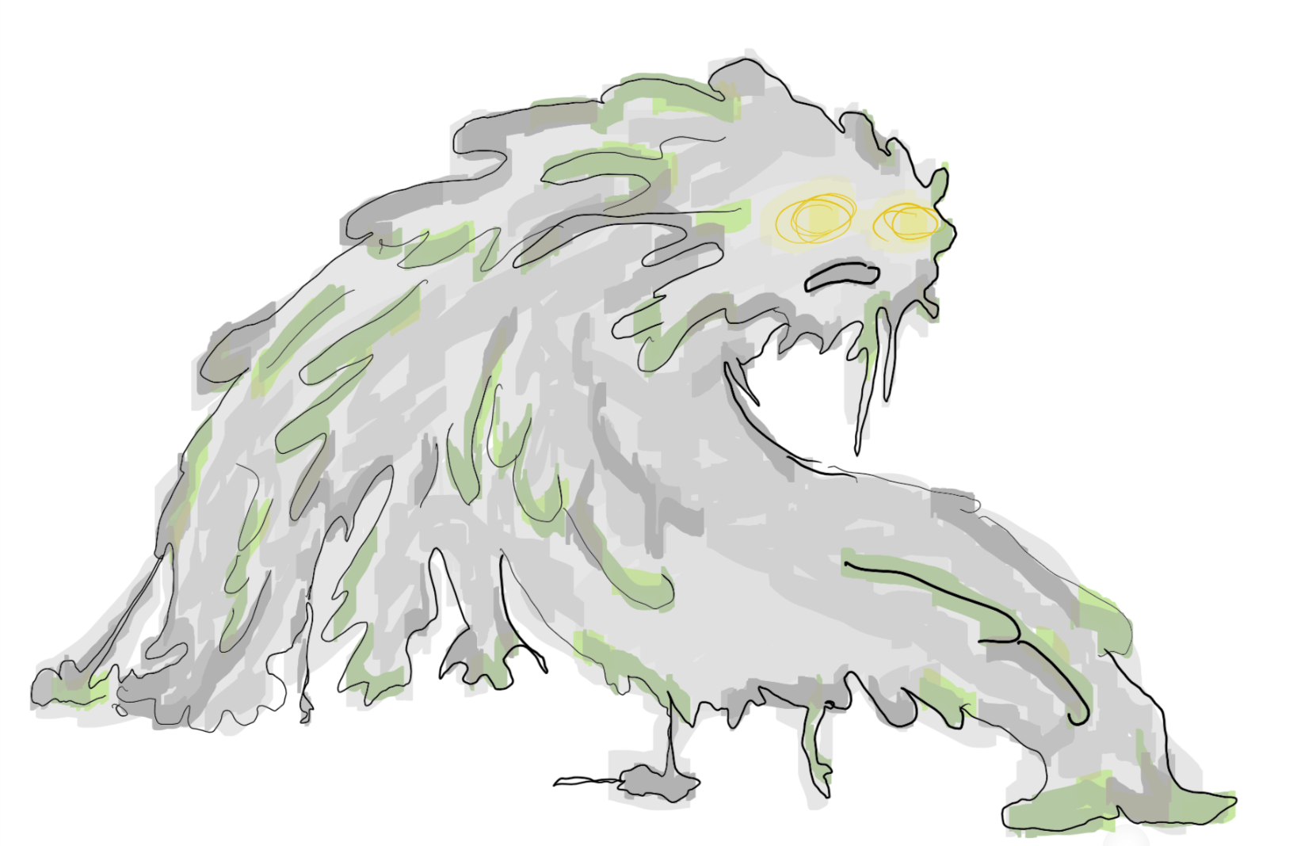
They meet a new kind of monster, completely covered with mud.
S: this is incredibly ugly!
C: and it stinks!

13 where they come out of the sewers, in the baths of the castle

Calcifer is the first to get out of the sewers, and begins to shake awkwardly to let the water out of the joints of the armor. Immediately after Heen shakes off the hair and wet Calcifer again. While calcifer complains, Sophie covers the visor of his helmet telling him to be silent. The Team is hiding in a locker room while in the central hall with the baths passes a platoon of patrol guards.

14 where (opt) thy decide to save civilians in prisons

Once in the prisons there are about twenty people.
S: and who would you be? Soldiers?
A clown with extremely sad makeup, sitting in the center of the largest cell rises and, moving in an absurdly theatrical way, responds.
C: we are the immune! The magic of slime has no effect on us. If we had a little bit of mud to prove it I would not fear to be the tester! Hahaha. We are in love and happy and positive with everyone. Layton instead hates us, because we are proof of his incompleteness. He can not even get the better of a poor clown, jester happy.
S: we will find a way to free you, you would be excellent allies for the resistance. Layton's kingdom must end!

*

In the prison, Sophie can speak with the released prisoners.
Clown: After escaping from an assault on the traveling circus, Ektor the tightrope walker and I get shelter in a poor hostel. That were the first times of the King's illness, and we were all afraid. When one day they came looking for us, I managed to save Ektor, at least.
S: Ektor is safe! You'll meet him at the den of the resistance!
C: What a wonderful news, I can not wait!
Ron the poet: They took me together with the clown, in the miserable hostel in the city. When they discovered they could not use us, they left us to rot. I have not eaten for days!
S: I should have some crackers.
R: oh my benefactress and liberator!
Zelda the good: I take care of the needy as I can.
S: are you an herbalist?
Z: yes, and not only, I studied medicine from a master, I will be able to help you.
Vlad the Barbarian: I come from a distant land, where I was a bear knight. Since I joined the army of Beuron as a mercenary, I never imagined that there would be a desertion. Now I find myself here without even understanding why.
S: now that you are free you could serve again, for our cause.

15 where they come to the throne room, where they defeat the soldiers

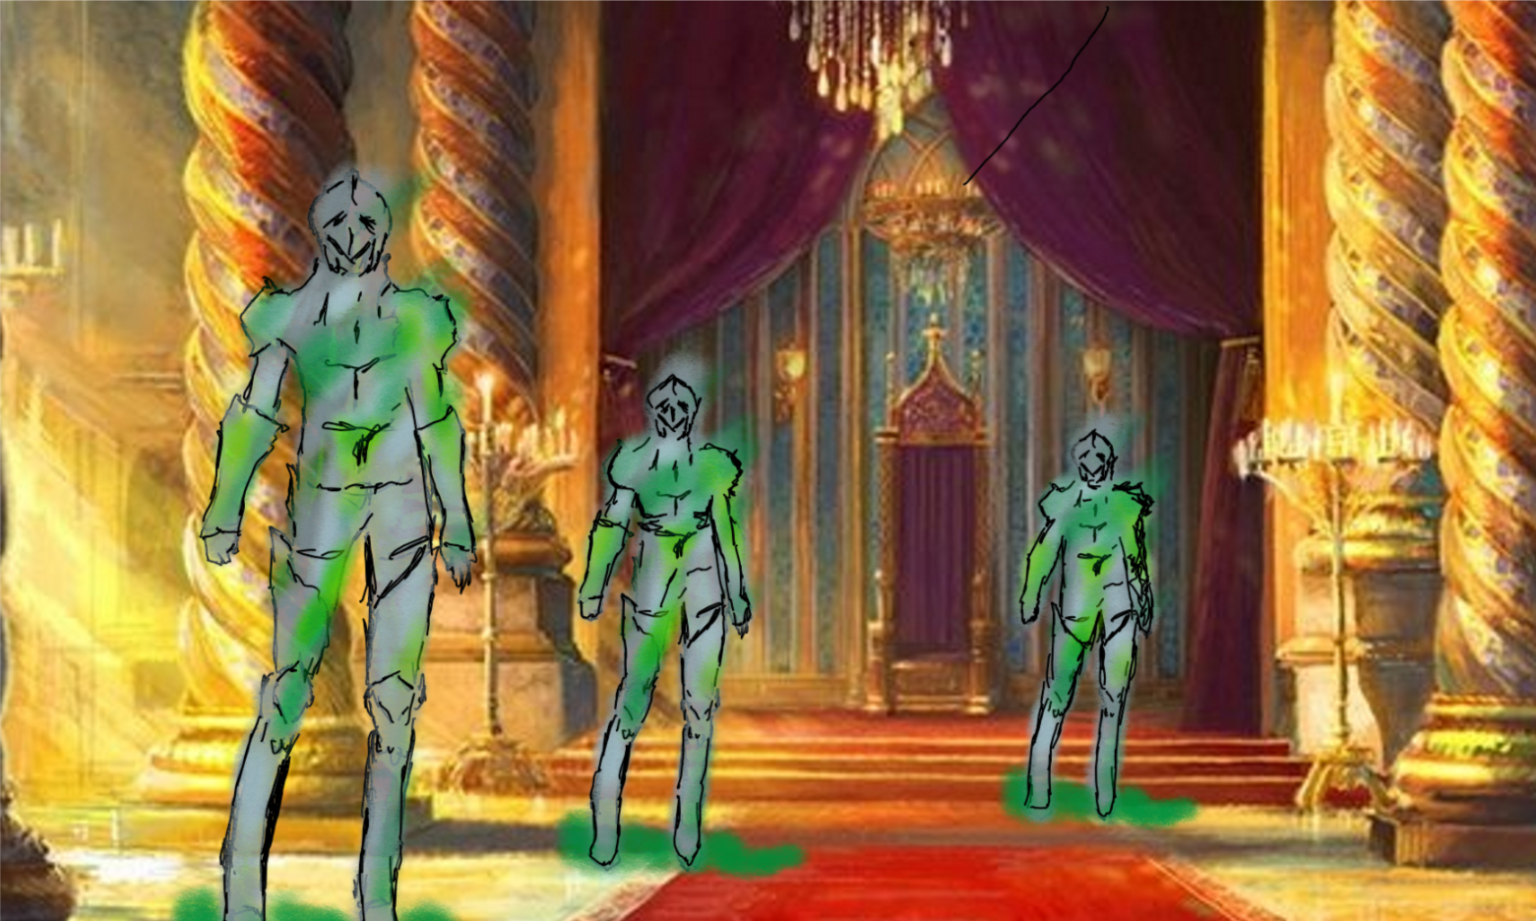
Once in the throne room they fight with the soldiers, who seem to be waiting for them standing forever. After the fight Sophie notes that their armor is dirty with mud from the marsh.
S: they wear the same armor of the night when Howl disappeared, they come from the swamp. But what have they been doing all this time? Can Layton keep them here waiting for death? They keep staring the void! It's a monster.
Meanwhile Markle Heen and Calcifer move the bodies stunned towards the baths with the pools.
M: give us a hand to free them, they are very heavy.

16 where Calcifer heats up the baths to save the soldiers

Sophie and her friends have opened the water channels and the water basin inside the boiler is full.
S: Calcifer, now it's up to you to heat up.
C: but we will need wood. A pool does not heat itself. Surely around here we will find it in abundance.

Recovered the wood and accumulated in a pile under the boiler calcifer blaze
C: we hate to heat water, it's a stupid task. We are made to cross planets!
S: Calcifer, think that you're saving so many lives and solving a war! Plus you're saving Howl!
C: certainly certain.
WoW: what a nice little fire, a huge little fire!

The heated water is drained into the baths, where the unconscious soldiers begin to return human.

*

While the defeated soldiers take a bath in the spa you can talk to some of them:
Soldier1: mmm, finally I'm fine, I've never been better
Soldier2: it's like being born again, now I can remember my name!
Soldier3 -distraught-: slime everywhere, it's like bringing the swamp inside.
Soldier4: I drank the water in which you are bathing us, and now I am terribly hungry.

17 Where they talk to the soldiers and Ben invites them to join the king.

In the rebel shelter
B: Welcome back! As I am pleased to see you come back with my brothers! The diversion that we created on the other side of the city cost us many wounded, we need new levers!
S: unfortunately they are all practically fainted, we will have to wait until they wake up ..
B - turning to the doctor-: bring me salts, we must act quickly, who knows what Layton is doing to Howl right now.
After using the salts on the guards
B: Hello soldiers, welcome back, do you remember me?
S1: Ben! You're safe and sound! Where are we?
S2: what happened to us?
S3: I remember we were fighting at the swamp, an army of Layton henchmen.
S2: Howl and Layton fought over our heads.
S4: I remember a deafening sound. Then howl fell into the river that runs through the swamp to Cal.
S1: I remember too, even though I was too busy fighting to be able to see well.
S4: Layton shone with a very strong light, I remember him, screaming that he could win any mage.
S: So Howl fell into the river?
S4: yes, and unfortunately, I think he was drowning.
B: The rapids of the river are terrible. Layton must have made him lose his senses and then let him die in the water. If he arrived at Cal's dam we would have seen him. I left a guard to watch it.
Sophie and the team exchange looks of despair.
C: could it not be somewhere along the river? Maybe with a head injury, or in a coma!
B: maybe, but I recommend you to go and get help from King Beuron, before proceeding to the swamps. He will certainly give you all the support he can to facilitate your journey.

*

Before leaving the shelter they can talk to some soldiers for more information on the battle, with members of the resistance and with the team members:
Soldier1: Howl fought well. For a moment, I thought we would win.
S: but have you seen what happened to Howl before he fells?
S1: no. I was too worried about staring at the blade that was trying to hit me.
Soldier2: I hope he is still alive, Simon has fallen into the rapid, and I myself have heard the sound of his head striking the boulders.
S: really heartening.
Calcifer does not speak.
Markle: I can not believe it, it's not true. It can not be, Howl would not let himself be defeated like that.

18 where they reach the walls talking about Howl

M: do you think that he's really drowned?
C -worried-: we really do not believe it. There should be an indissoluble bond between us. I'm sure if he was dying we would be the first to know it. What absurdity, Howl dead.
S: Do not be afraid, Calcifer, he’s fine, I'm sure too. We just have to hurry up to find it, before all these people are destroyed by Layton's madness.
C: we are not afraid, we are really sure to have a link with Howl, if he feels bad we would know it.

